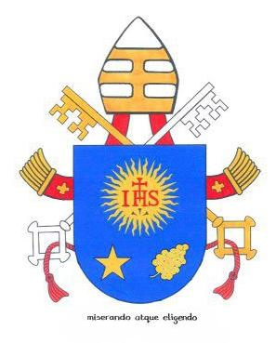
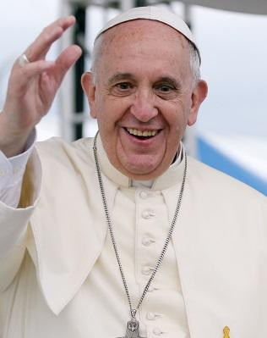
“Behind and before every vocation to the priesthood or consecrated life there is always the strong and intense prayer of someone: a grandmother or grandfather, a mother, a father, a community… Vocations are born in and from prayer; and only through prayer can they persevere and bear fruit.” ~ Pope Francis

“I appeal to you, brothers and sisters, by our Lord Jesus Christ and by the love of the Spirit, to strive together with me in your prayers to God on my behalf” ~ St. Paul (Romans 15:30)

Welcome to this year’s Spiritual Adoption Prayer Initiative! Thank you for being willing to welcome into your life of prayer the intentions and growth of a Seminarian. By accepting this invitation, you are taking this man into your spiritual home and offering to prayer on his behalf to our Lord for the spiritual graces and care that he will need this year. As one Church, and one mystical body of Christ, we are charged in Scripture with caring for the spiritual needs of our brothers and sisters in the faith. Thank you for saying yes to give the greatest gift of all - your prayer.

You are your family have been paired up with ________________. Attached is a short biography and photo of him. We hope that he becomes more than just a name this year, but also that his biography lets you get to know him a bit better.

The way that this works is that, whenever you gather in prayer, personally or as a family, you can offer up some of your prayers for the young man you have agreed to spiritually adopt. We’ve attached a suggested prayer but feel free to use any prayer(s) that you prefer. The goal is to pray for the graces that he needs, on a consistent basis. We have also included the email of the young man - feel free to contact him if you wish: _________________. This is entirely optional but encouraged. He has been informed of your name and will offer prayers for you as well.

If you have any questions about your role, how to proceed, or anything else regarding this initiative, please don’t hesitate to reach out to ___________ at ____________________.

Thank you again for supporting vocations through your prayers!

In Christ,

Vocation Ministry

