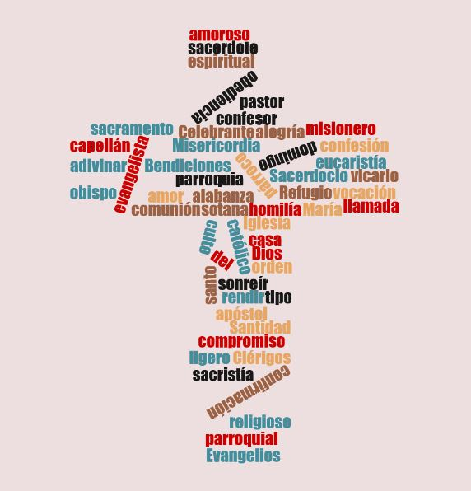

Padre ________________________________

______________________________________________________________________________________________________________________________________________________________________________________________________________________________________________________________________________________________________________________________________________________________________________________________________________________________________________________________________________________________________________________________________________________________________________________________________________________________________________________________________________________________________________

