Lord Jesus,
as You once called the first disciples to make them fishers of men,

HOW CAN
YOU

let Your sweet invitation continue to resound:
Come, follow Me!
Give young men and women the grace of responding quickly to Your voice.
Support our bishops, priests, and consecrated people
in their apostolic labor.
Grant perseverance to our seminarians and to all those who are carrying out the ideal of a life
totally consecrated to Your service.
Mary, Mother of the Church, the model of every vocation, help us to say ‘Yes’ to the Lord Who calls us to cooperate in the divine plan of salvation.
Amen.

-Pope St. John Paul II

Creating a Culture of Vocations
www.vocationministry.com

HELP PROMOTE
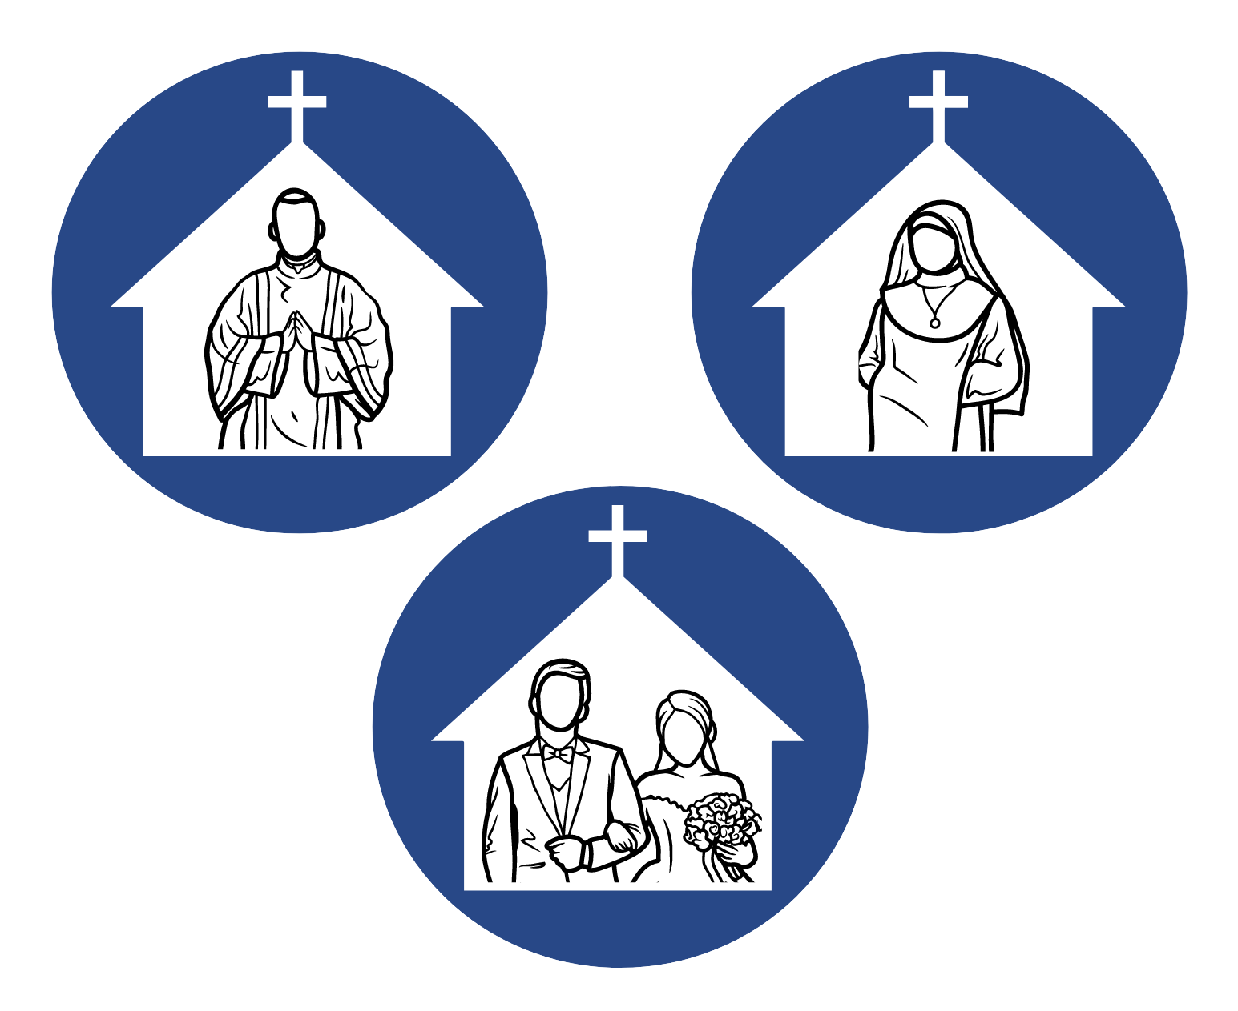
VOCATIONS IN YOUR PARISH?
A parish vocation ministry ensures that every parish fosters an environment where each baptized person can joyfully explore the potential of God’s call in his or her life by providing resources for prayer and discernment.

IN THE UNITED STATES…
The average age of a diocesan parish priest is 67 YEARS OLD
42 dioceses DID NOT ordain a new priest in 2021
Over the past 50 years, the number of sisters has declined 74%
Catholic marriages have dropped
67% since 1970
These startling statistics highlight the importance and absolute
necessity to encourage vocations to the priesthood, religious life, and sacramental marriage.
FOUR TYPES OF MINISTRY ACTIVITIES FOR FLOURISHING VOCATIONS

Prayer Awareness & Education
Youth Affirmation

“Let us be quite frank: the ability to cultivate vocations to the priesthood and the religious life is a sure sign of the health of a local Church. There is no room for complacency in this regard. God continues to call young people: it is up to all of us to encourage a generous and free response to that call.”

-Pope Benedict XVI in his address to the United States Bishops in 2008

We meet monthly for fellowship, prayer, and planning.

JOIN US!

